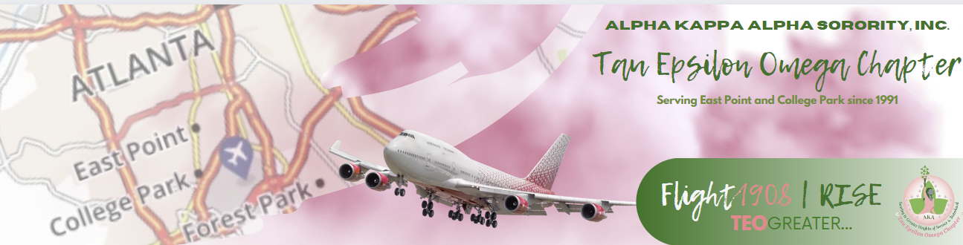 **Connections & Social Action Committee Agenda**

*November 2024 Committee Meeting*

*November 4, 6:30 PM*

*Zoom*

[*https://us02web.zoom.us/j/9952637222?pwd=aldZa0t2a0ExTEdZUDhlZWRTeWlEQT09&omn=82697195911*](https://us02web.zoom.us/j/9952637222?pwd=aldZa0t2a0ExTEdZUDhlZWRTeWlEQT09&omn=82697195911)

*Meeting ID: 995 263 7222*

*Passcode: pinkivy*

**Summary:** Article I, Section 15, (i) of the Constitution and Bylaws provides that: the Connection Committee “shall consist of a chairman and a representative from each region. The Committee shall identify and study national and international issues which impact quality of life, design strategies for communication with the membership regarding issues, and mobilize the membership for action to formulate and recommend position statements to the Supreme Basileus and/or the Directorate.

* Call to Order
* Party at the Polls Update
* Advocate for Social Justice Budget Review
* 2024 Activity Leader Accolades
* State Election Board Update
* 2025 MLK Day Activity Ideas
* 2025 Georgia AKA DC: January 27, 2025

**Budget Update:**

|  |  |
| --- | --- |
|  | Committee| Officer (i.e. Program Committee) |
| **Total 2024 Budget** | $3500 |
| **Expenditures to Date** |  |
| Budget Remaining |  |
|  |  |

**Upcoming Meeting and Events:**

|  |  |  |
| --- | --- | --- |
| **Date & Time** | **Subject** | **Location Information** |
| **December 2 @ 6:30 PM** | **Committee Meeting** | **Zoom** |
|  |  |  |
|  |  |  |
|  |  |  |